**APPLICATION PROGRAMMING PRACTICLE FILE**

**NAME – RISHAP KUMAR**

**ROLL NO. – 11911041**

**BRANCH – CSE**

**INDIAN INSTITUTE OF INFORMATION TECHNOLOGY, SONEPAT**

**INDEX**

1. **HTML FORM using BOOTSTRAP 4.0**
2. **iphone HTML homepage using BOOTSTRAP 4.0**
3. **Finding max number of three numbers given by user(JAVASCRIPT)**
4. **JAVASCRIPT function to convert Fahrenheit to Celsius.**
5. **Adding a number and a numeric string, the result will be a concatenated string(JAVASCRIPT).**
6. **2-D array using PHP**
7. **Connecting to SQL using PHP**
8. **checking a given number is palindrome or not using PHP.**
9. **HTML FORM using BOOTSTRAP 4.0**

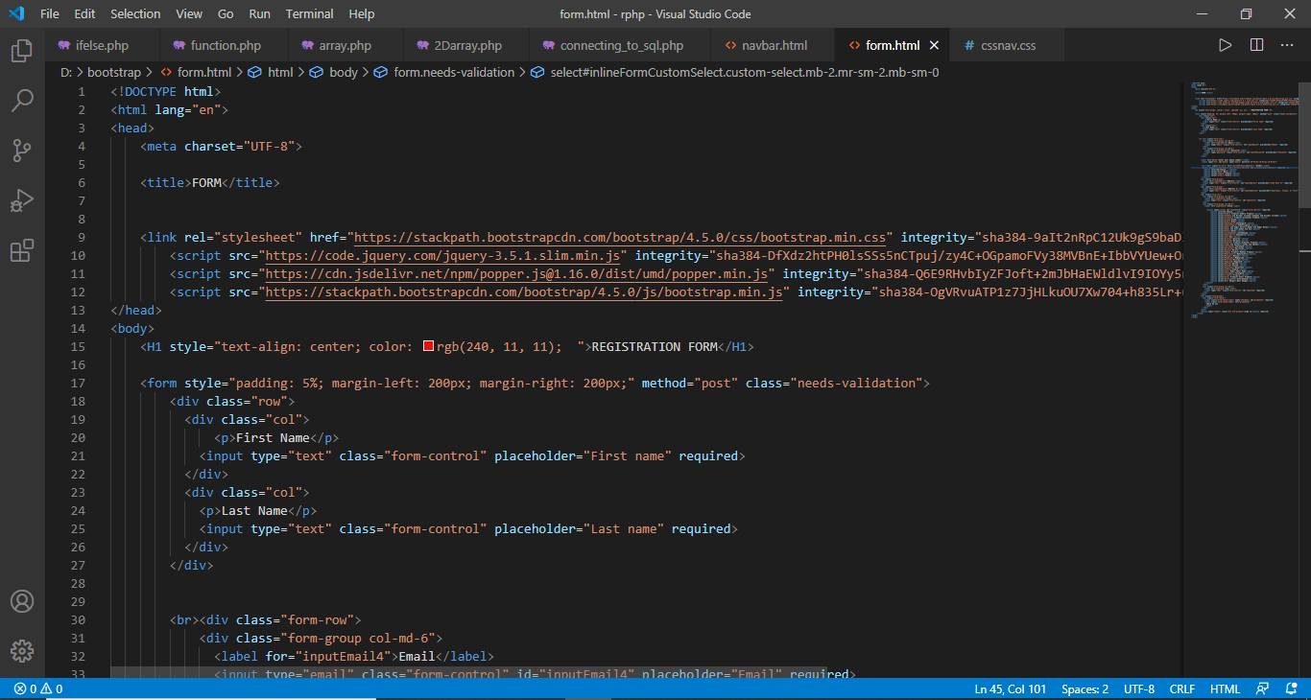

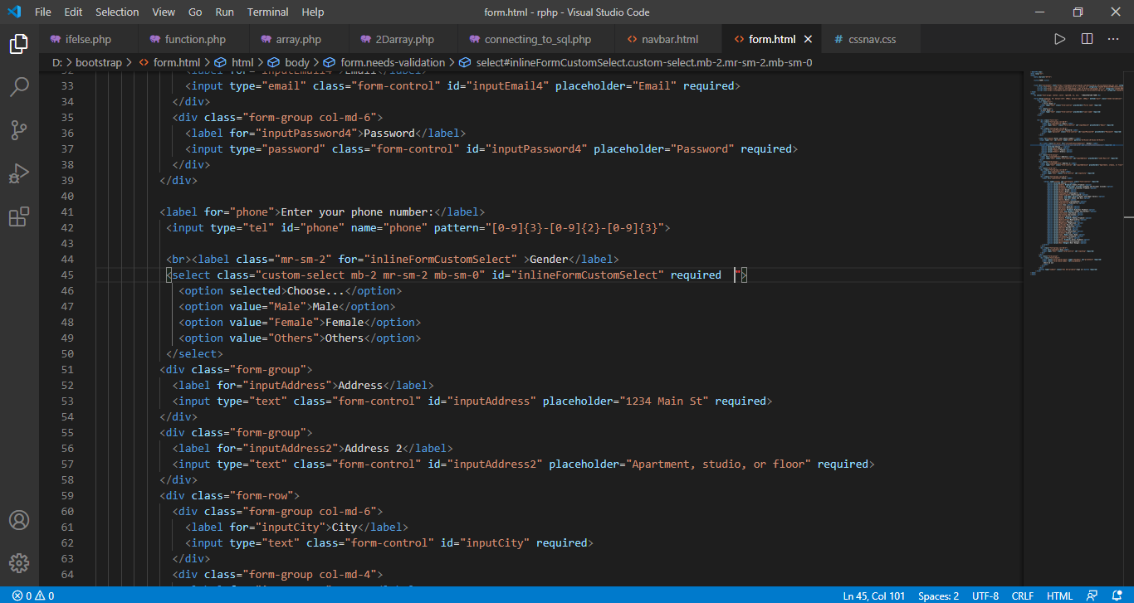

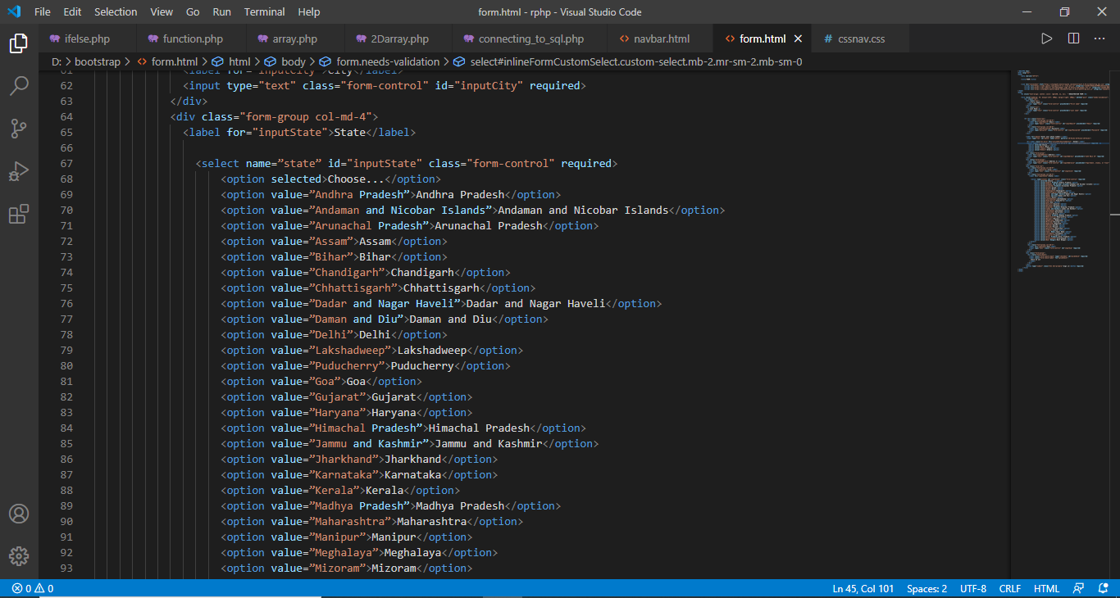

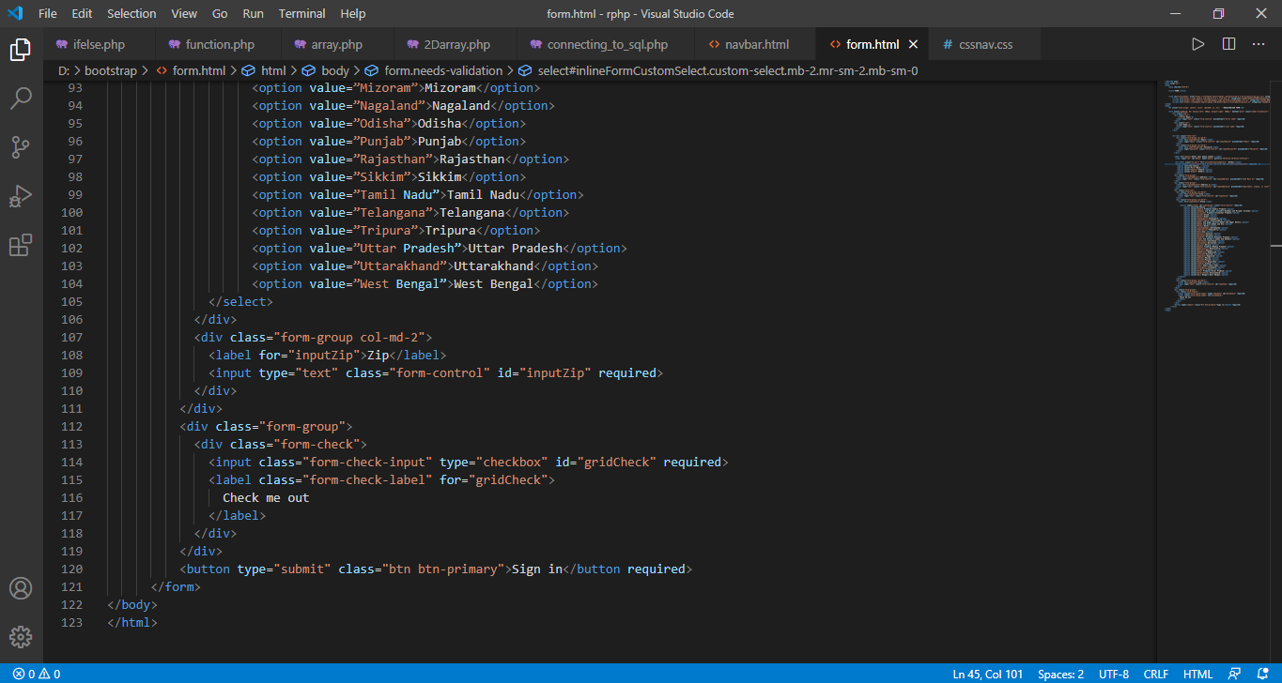

**Output:-**

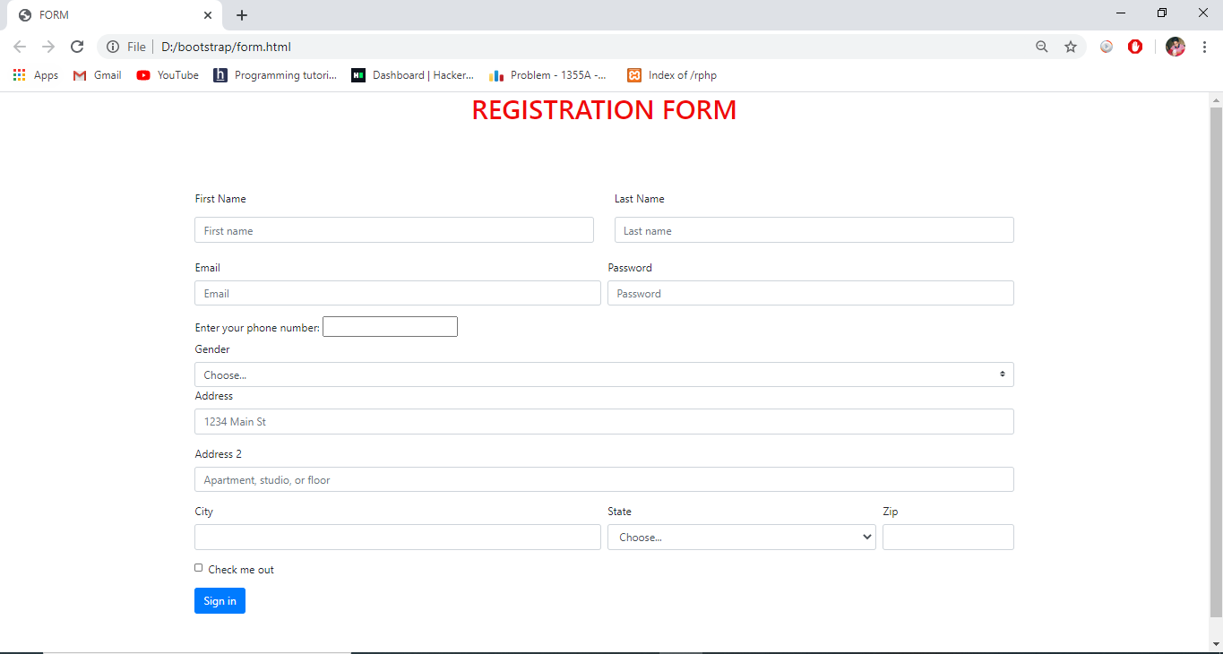

1. **iphone HTML homepage using BOOTSTRAP 4.0**

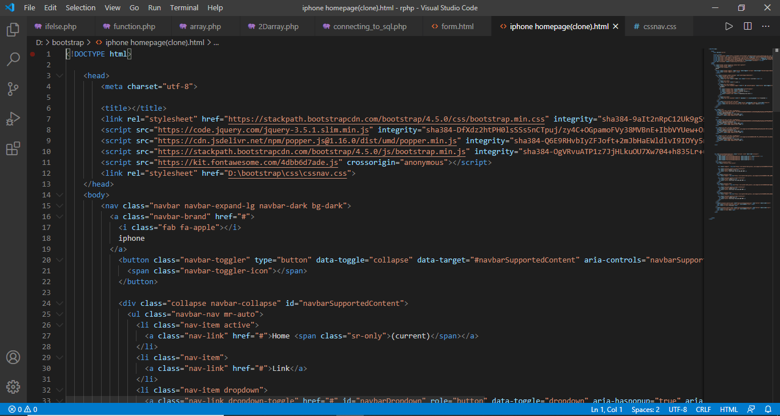

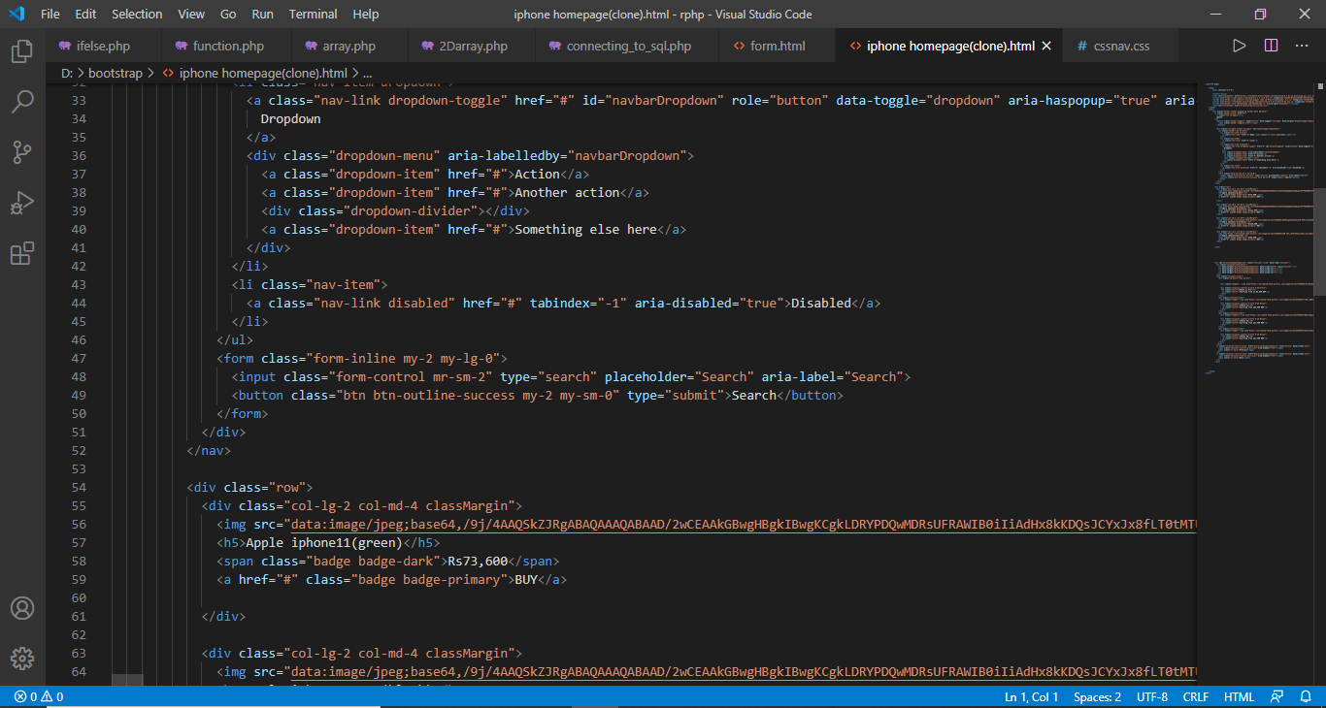

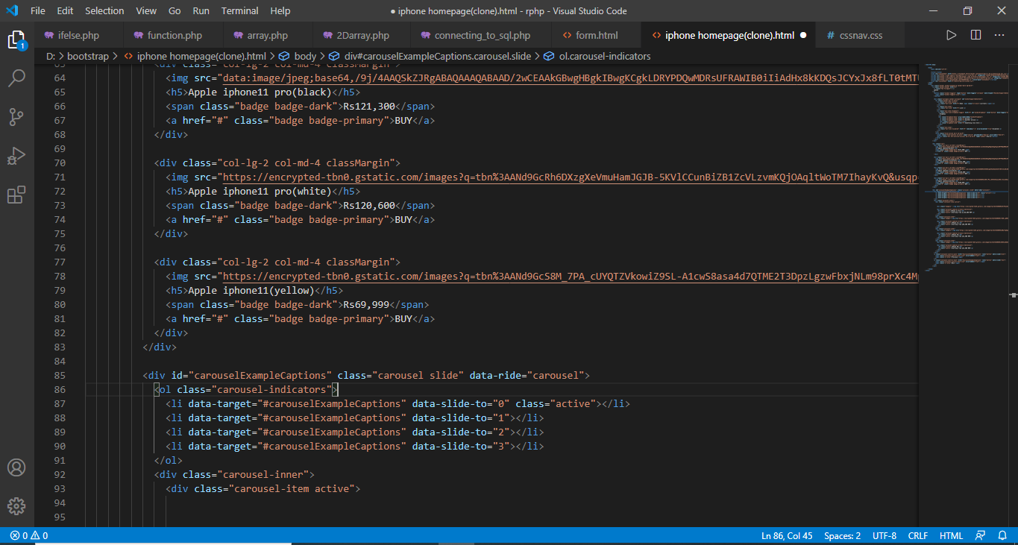

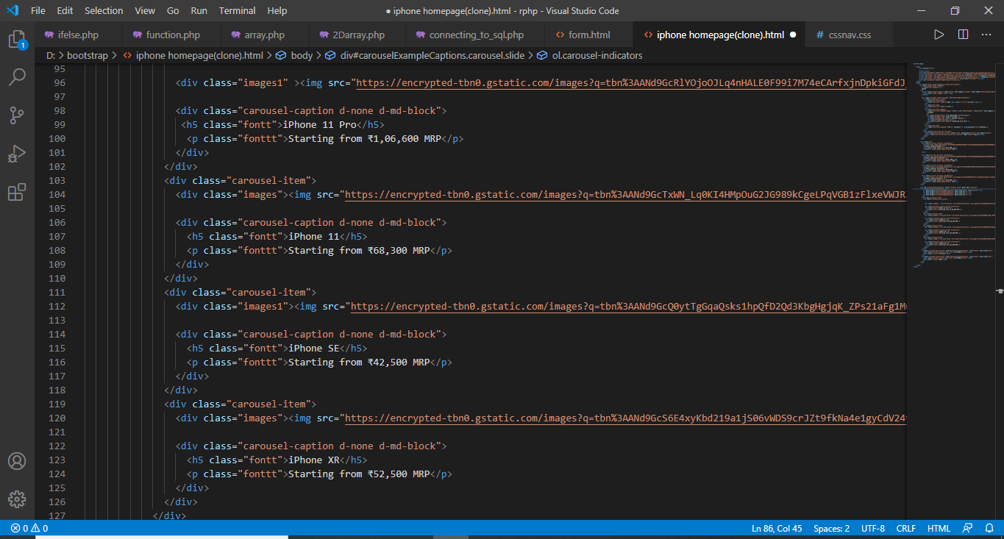

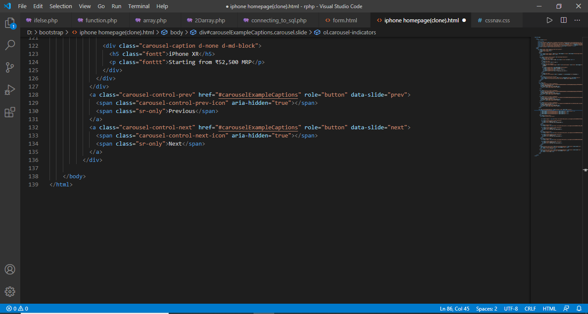

**Css file:-**

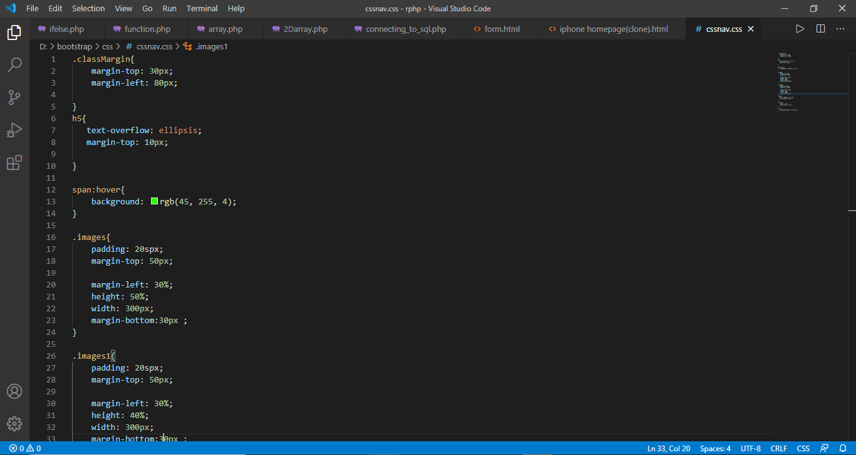

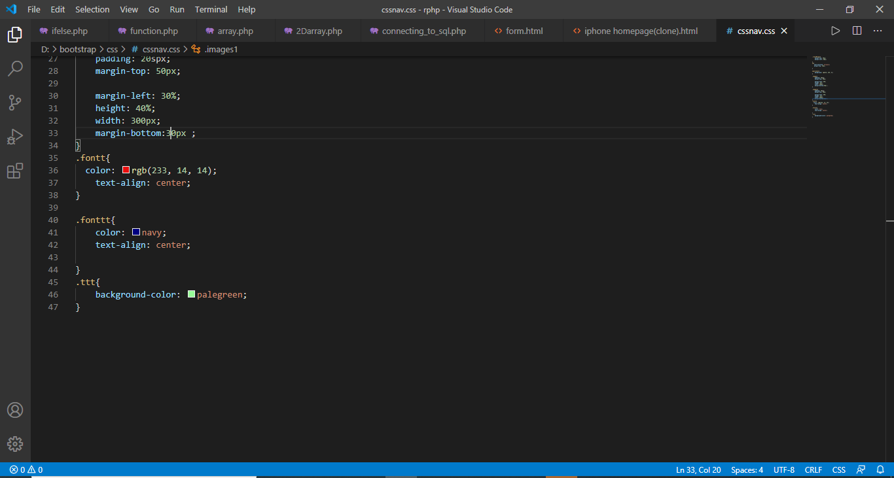

**Output:-**

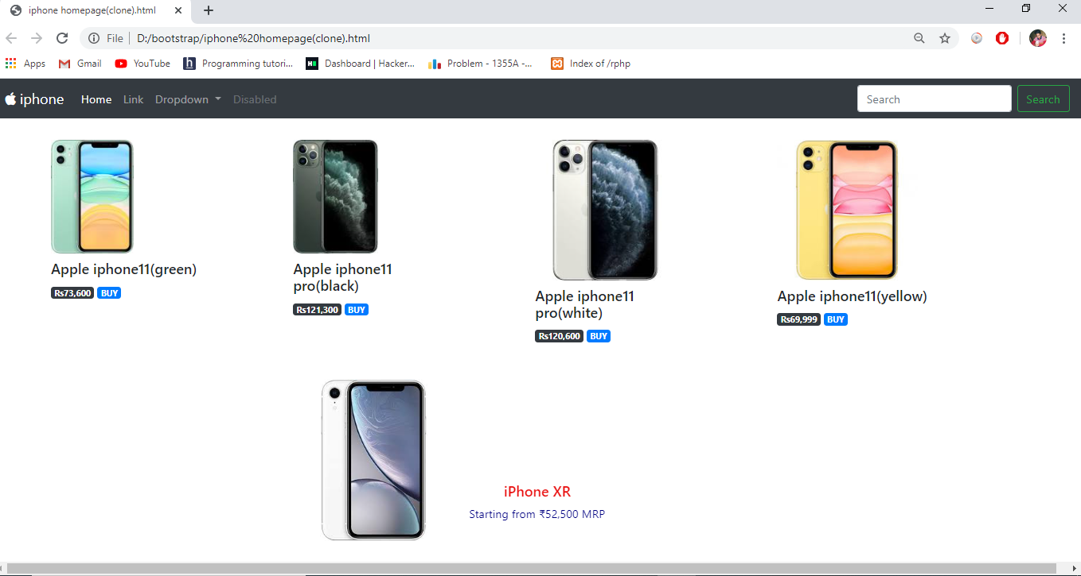

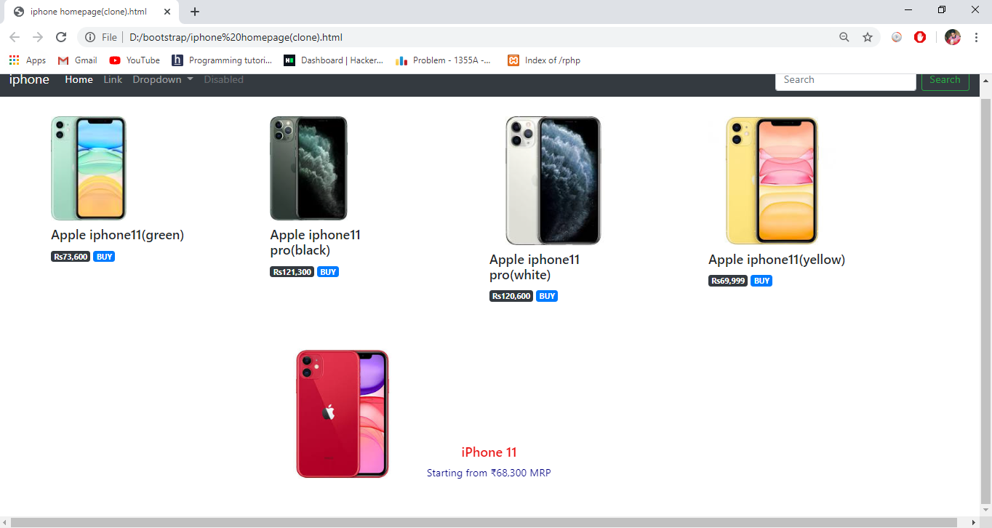

1. **Finding max number of three (JAVASCRIPT)**

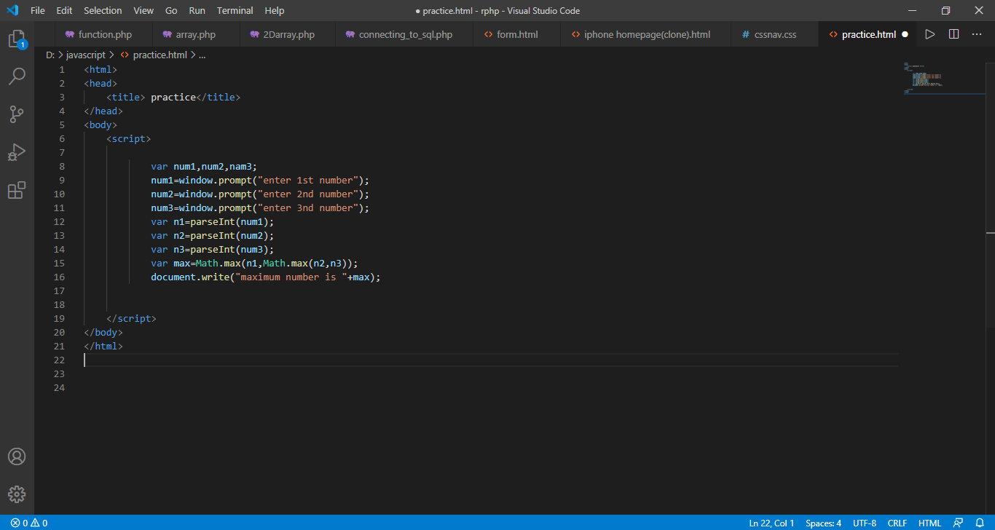

**Output:-**

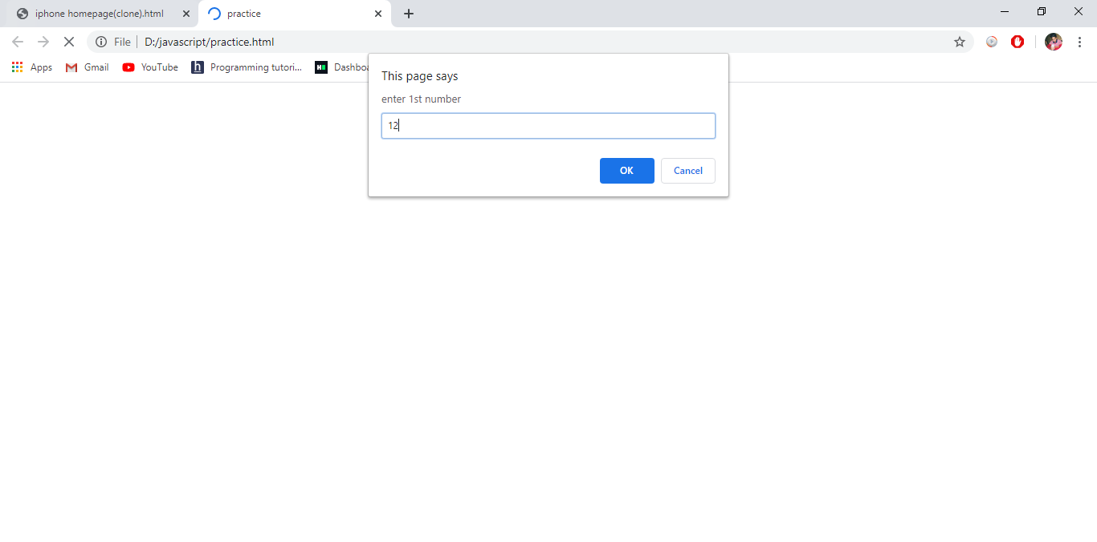

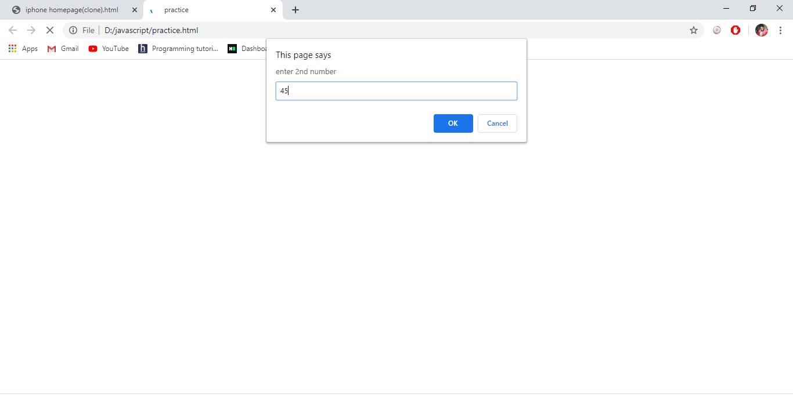

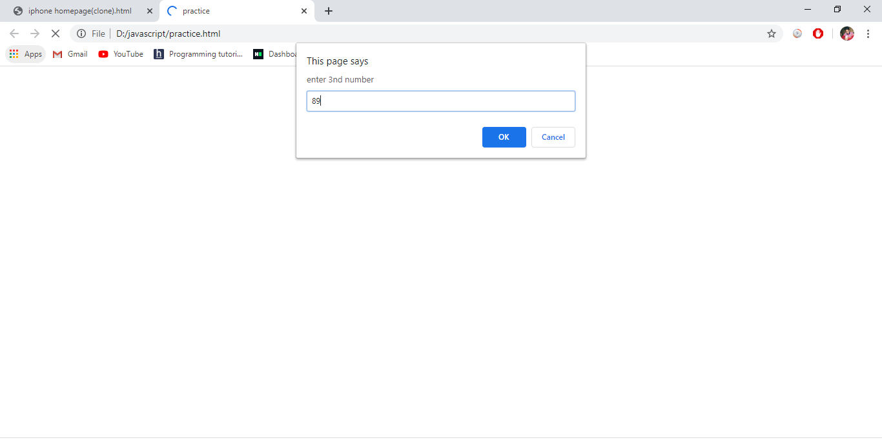

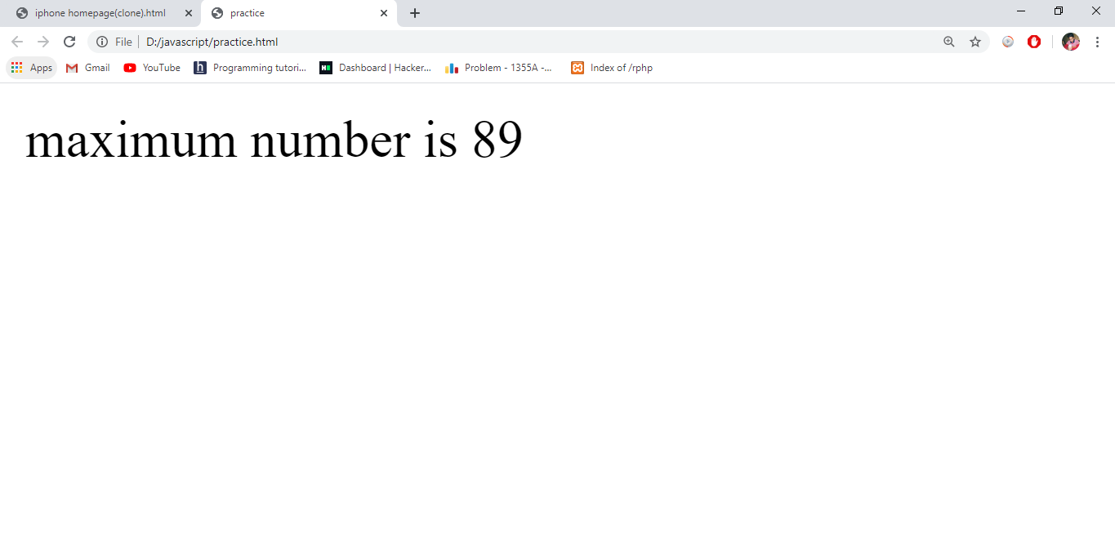

1. **JAVASCRIPT function to convert Fahrenheit to Celsius.**

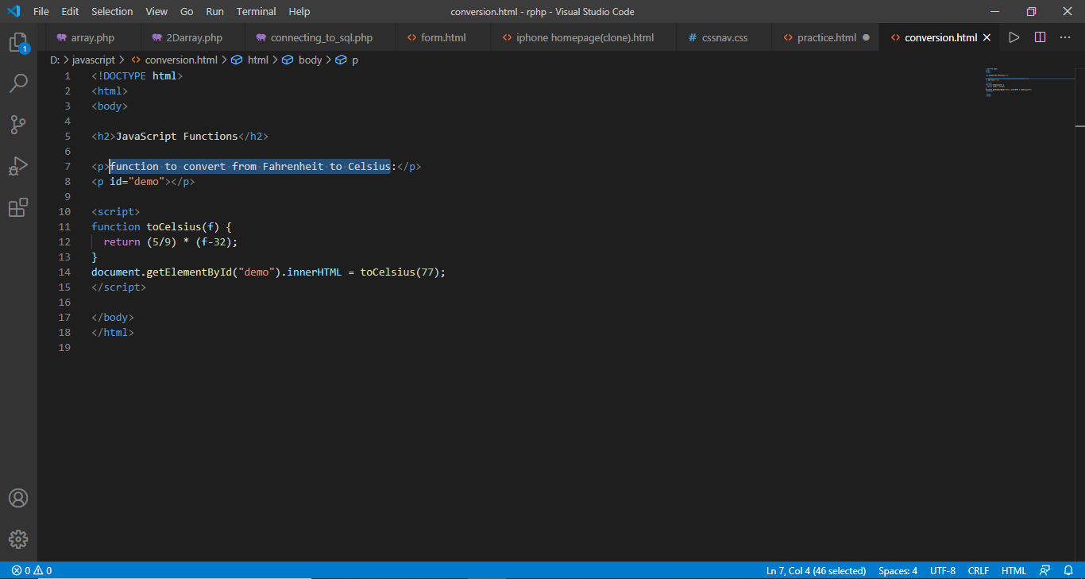

Output:-

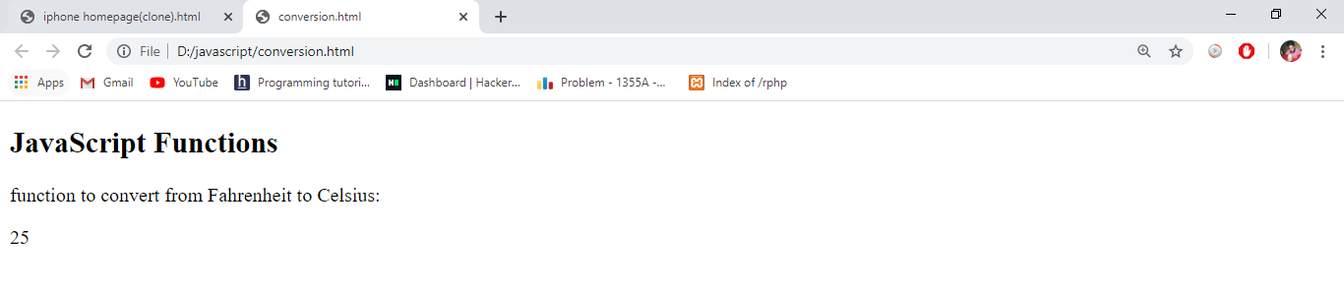

1. **Adding a number and a numeric string, the result will be a concatenated string(JAVASCRIPT).**

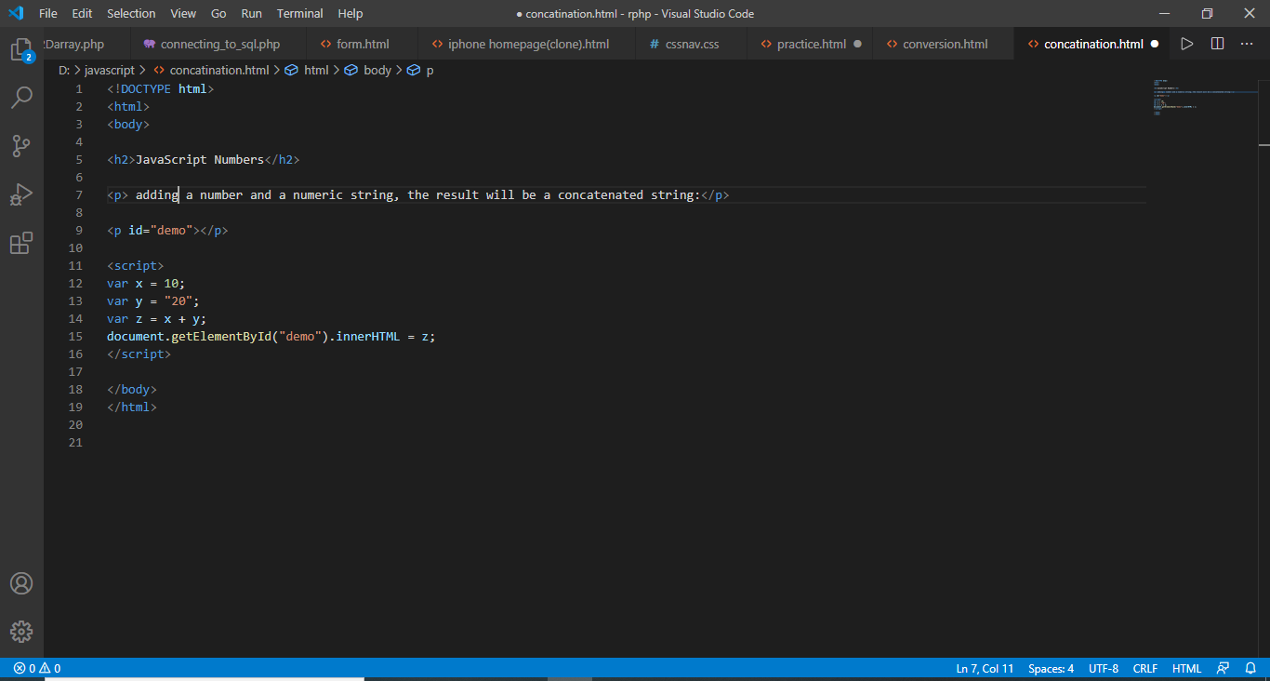

**Output:-**

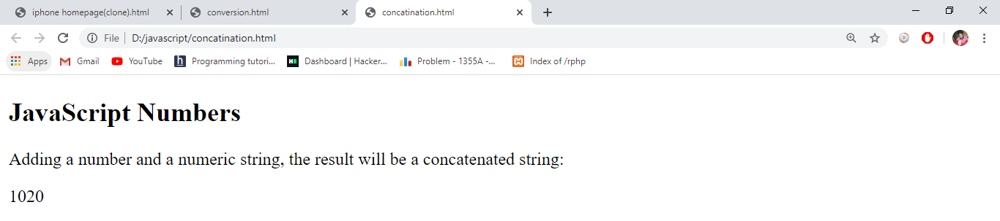

1. **2-D array using PHP**

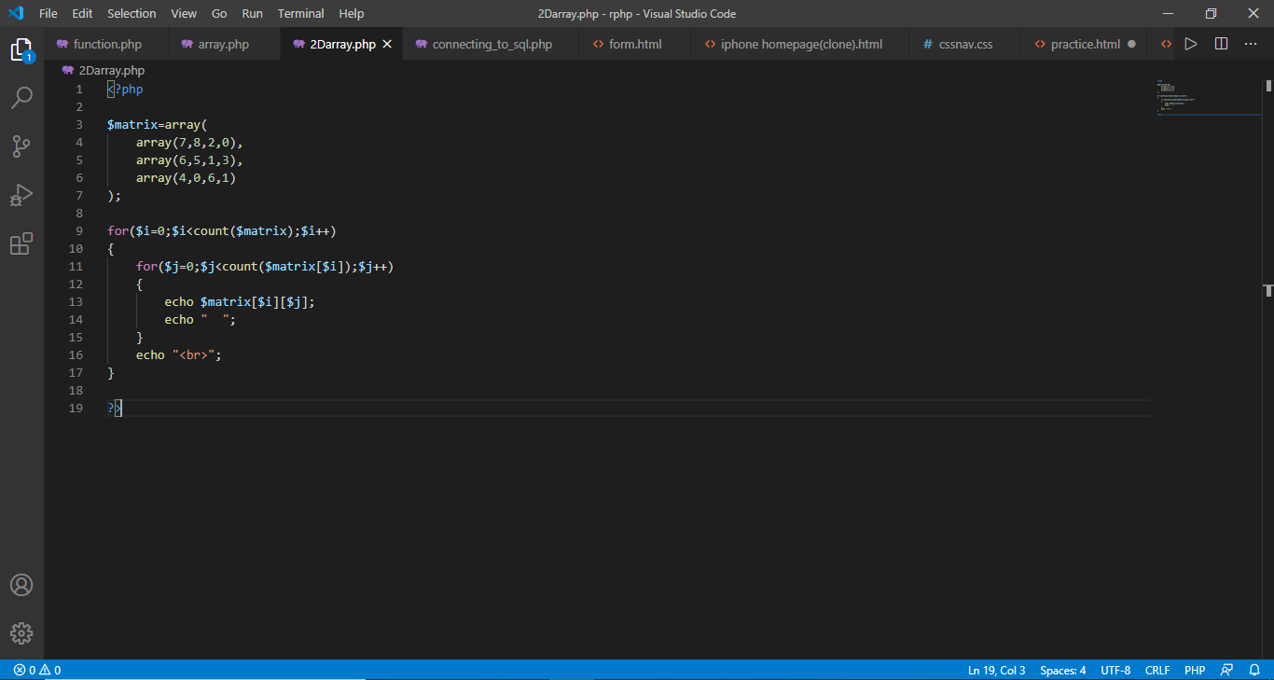

**Output:-**

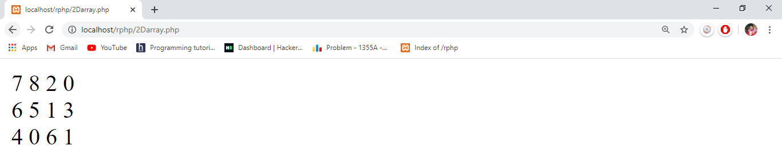

1. **Connecting to SQL using PHP**

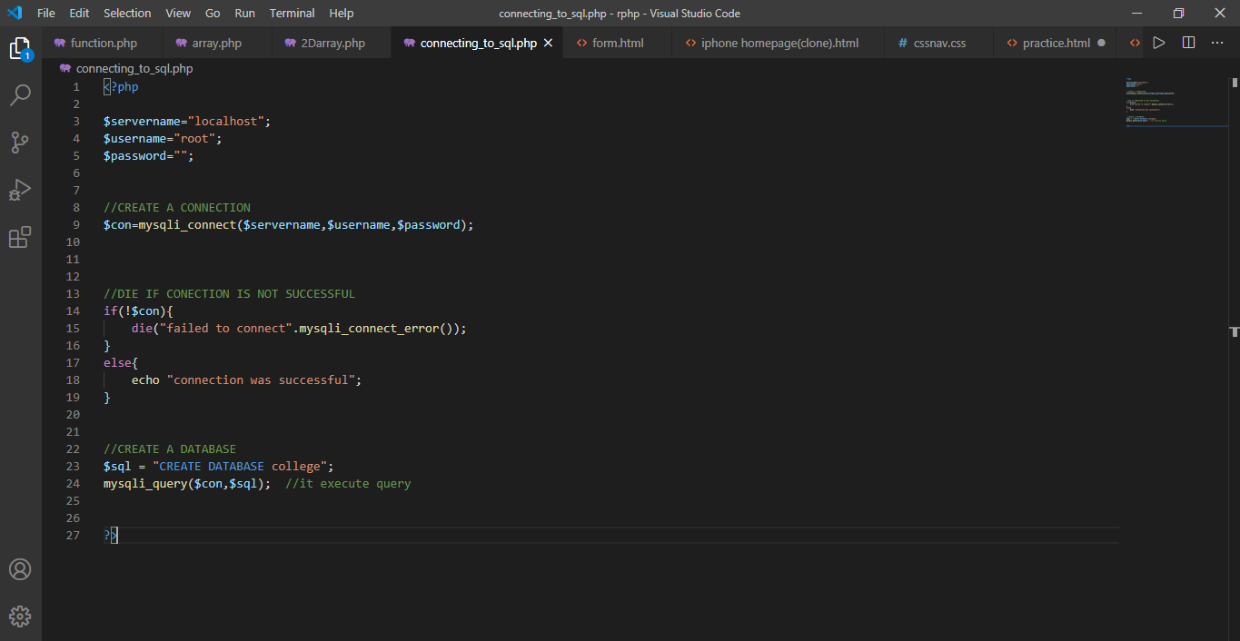



1. **checking a given number is palindrome or not using PHP.**

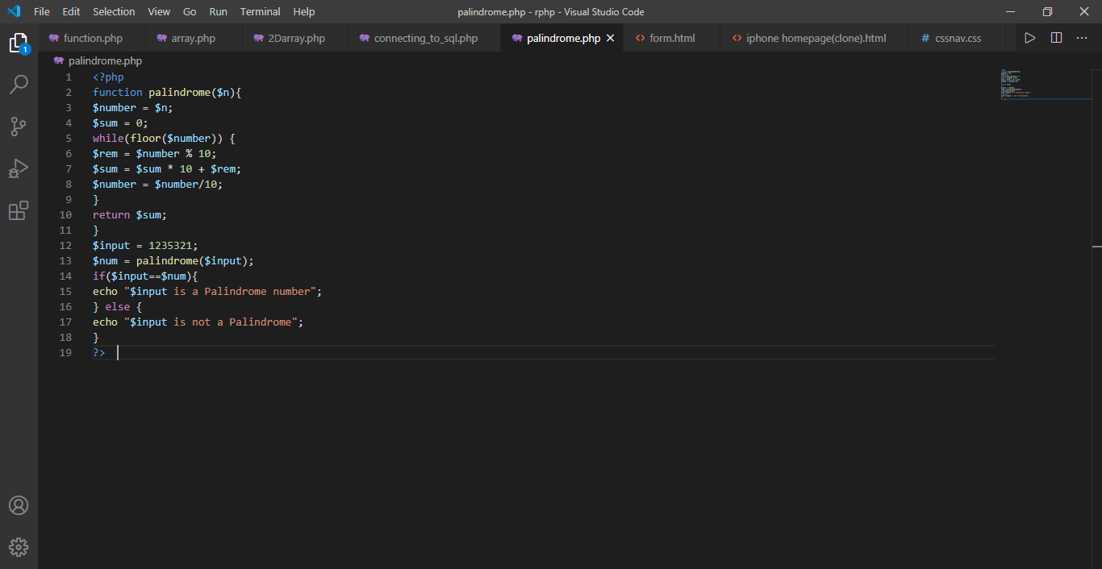

**Output:-**

